|  |
| --- |
| Renal Healthcare Association Healthcare Information Exchange for EQRS logo |
| Renal Healthcare (RHA)  Healthcare Information Exchange (HIE)  Contracting User Guide |
|  |
| VERSION 2.0 |

05/14/24

**Proprietary Statement**

This document was developed specifically for Renal Healthcare Association (RHA). The concepts and methodologies contained herein are proprietary to RHA. Duplication, reproduction, or disclosure of information in this document without the express written consent of RHA is prohibited.

The electronic version of this document is the latest revision. It is the responsibility of the individual to ensure that any paper material is the current revision. The printed version of this document is uncontrolled.

All Trademarks, Registered Trademarks, Service Marks, and brand and product names used in this document are the property of their respective owners.

© Copyright 2024 Renal Healthcare Association. All rights reserved.

**Review and Revision History**

This process document is reviewed to ensure its relevance to the systems and processes it describes. Changes are documented at a high level.

| Date | Version | Description of Change  (Affected Sections) |
| --- | --- | --- |
| 05/18/12-01/17/21 | 1.00-1.06 | Phase 1 HIE:   * Edits and pictures inserted * NRAA logo updated * NRAA address updated * Updated for EQRS * Updated for Renal Healthcare branding |
| 05/14/24 | 2.00 | Phase 2 HIE:   * Updated for website enhancements |

TABLE OF CONTENTS

1 Introduction 1

1.1 Purpose 1

1.2 Intended Audience 1

2 Getting Started (Pre-Onboarding) 1

2.1 Become Familiar with Onboarding Steps 1

2.2 Internal Review of Contract Documents 1

2.3 Assemble Contract Information 2

2.3.1 Contract Authority & Business Contact Designation 2

2.4 Contract Execution 2

3 Onboarding 3

3.1 Create HIE Login Account 3

3.1.1 New Login Requests 3

3.1.2 Existing Login 4

3.2 Submit Contract Information 5

3.2.1 One Contract Per Organization 7

3.3 Contract Approval 7

4 Completion 7

4.1 Support 7

5 Next Steps 8

5.1 Facility Registration Overview 8

5.1.1 Pre-Facility Registration 8

5.1.2 Facility Registration Process 8

5.2 EHR Vendors Overview 8

Appendix A – Acronyms 9

TABLE OF TABLES

Table 1: Acronyms 9

TABLE OF FIGURES

Figure 1: HIE Login 3

Figure 2: RHA HIE Signup 4

Figure 3: Electronic Record and Signature Disclosure 5

Figure 4: Adopt Your Signature 6

# Introduction

The Renal Healthcare Association (RHA) works in partnership with the Centers for Medicare & Medicaid Services (CMS) to support submission of End Stage Renal Disease (ESRD) dialysis facility and patient data into the CMS ESRD Quality Reporting System (EQRS) via an electronic Health Information Exchange (HIE) platform. Various healthcare technology partners, Electronic Healthcare Record (EHR) vendors, and dialysis facilities contract with the RHA to leverage the data services offered by the RHA HIE. To participate in the RHA HIE, an organization must execute the HIE Participation Agreement, enter their organization information, and receive an official approval to onboard using the HIE platform.

## Purpose

The purpose of this document is to provide instructions to onboard with the RHA HIE for electronic data submission of EQRS quality data.

## Intended Audience

This document is intended for:

* Individuals at renal dialysis organizations with contracting authority, and will be the signatory for the online contracting process.
* The primary renal dialysis organization’s business or designated contact who can provide additional contracting information to RHA if needed.

# Getting Started (Pre-Onboarding)

The contracting application is designed to facilitate efficient and timely participation in the RHA HIE. The following steps will help organizations prepare for the onboarding process.

## Become Familiar with Onboarding Steps

Before beginning the onboarding process, go to the [RHA HIE](https://rhahie.org/) website (https://rhahie.org/).

* On the [Home](https://rhahie.org/) page (https://rhahie.org/), review the four steps to onboard.
* On the [Contracting](https://rhahie.org/Contracting) page (https://rhahie.org/Contracting), review the three steps to apply for a contract to execute the HIE Participation Agreement.

## Internal Review of Contract Documents

On the [Contracting](https://rhahie.org/Contracting) page (https://rhahie.org/Contracting),

* In Step 1, download the Contract Sample and Terms & Conditions documents. The fees displayed in Step 2 are also included in the Terms & Conditions document.
* Circulate these documents for review and approval with the appropriate individuals in your organization, including business, finance and legal entities.
* Identify any questions or requests you would like considered by the RHA.
* Send your questions and requests for contract consideration before you begin the process to:

Renal Healthcare Association

19 Mantua Road

Mount Joy, NJ 08061

Email: [hie@renalhealthcare.org](mailto:hie@renalhealthcare.org)

Telephone: (215) 320-4655

Fax: (215) 564-2175

## Assemble Contract Information

Before starting the contracting process, assemble the following information:

* Contracting organization name
* Organization Doing Business As (DBA) name (if applicable)
* Contracting organization address, city, state and zip code
* Designated business contact information – Reference Section 2.3.1 for more information
* RHA membership status - You will be asked to indicate if you are a Renal Healthcare Association member
* Organization size – This is the monthly average number of ESRD patients your organization provides dialysis treatment to across all the facilities you will list as covered by the contract

### Contract Authority & Business Contact Designation

The RHA HIE contracting process must be performed by an individual at the organization who has contracting authority. The contracting process uses the login account established by the individual providing the information as the electronic signature for the contract execution.

During the contracting process, the contracting authority has the option to delegate receipt of future communications regarding the RHA HIE contract to a designated business contact in the organization. Please have the following information available if you plan to designate a business contact:

* Name
* Address
* Business telephone number
* Business email address

## Contract Execution

When you reach the end of the contracting process, the contract is executed using DocuSign electronic signature software. Your electronic signature (as authorized by your username and password) along with a date and time stamp will submit the contract to RHA for review and approval.

# Onboarding

Once [Section 2.0 Getting Started (Pre-Onboarding)](#_Getting_Started_(Pre-Onboarding)) tasks are completed, go the [Contracting](https://rhahie.org/Contracting) page (https://rhahie.org/Contracting). Click on the *Apply for a Contract* button and follow these instructions.

## Create HIE Login Account

Figure 1 provides a screenshot of the HIE Login page.

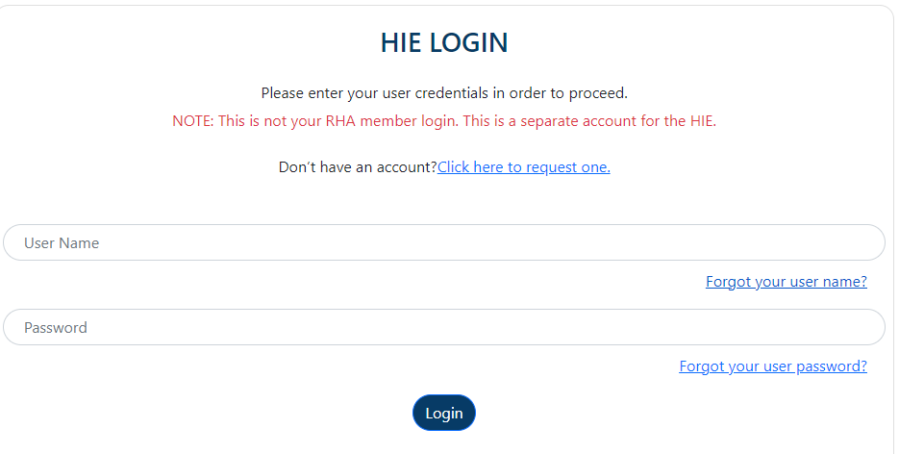

**Figure 1: HIE Login**

### New Login Requests

* To create a new account, select “Click here to request one” on the HIE Login page. (Reference Figure 1)
* The RHA HIE Signup page will display. Enter First Name, Last Name, User Name, Email, and Password following the criteria provided for each. Click “Create Account” to submit the request. (Reference Figure 2)

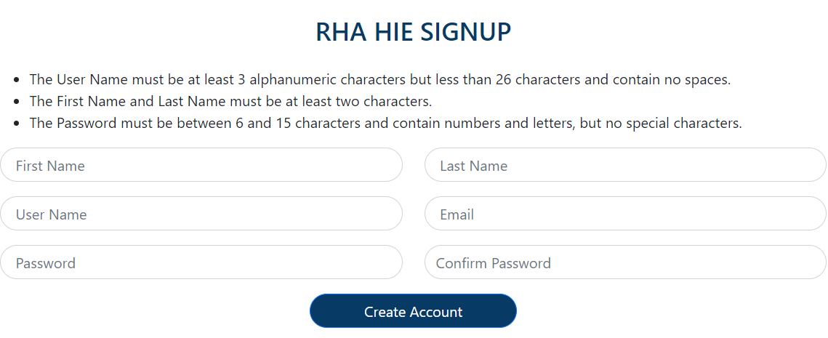

**Figure 2: RHA HIE Signup**

* An HIE Email Verification message will display confirming the account has been created and redirecting to the email associated with the request for further information.
* An email from the RHA HIE Help Desk is delivered to the email associated with the request providing instructions to activate the new account. Activation is performed by selecting the “Click here” link in the email.
* An HIE Account Activation message will display confirming the new account has been activated. A “Click here” link is provided to redirect to the HIE Login page.
* On the HIE Login page (Figure 1), enter the User Name and Password associated with the new account and click “Login”. The HIE Organization Registration page will display to continue the onboarding process.

### Existing Login

* On the HIE Login page (Figure 1), enter the User Name and Password associated with the account. Click “Login”.
  + If the HIE Organization has already been created, then the Facility Registration page will display to continue the onboarding process.
  + If the HIE Organization has not been created, the HIE Organization Registration page will display to continue the onboarding process.
* Click “Forgot your user name?” or “Forgot your user password” and provide the email associated with the Login. Instructions to retrieve and/or reset this information will be sent to the email provided.

## Submit Contract Information

* On the HIE Login page (Figure 1), enter the User Name and Password. Click “Login”. The HIE Organization Registration page will display to continue the onboarding process.
* On the HIE Organization Registration page, enter the organization information defined in Section 2.3 Assemble Contract Information. Click “Submit”.
* The HIE Organization Registration Signature/Edit page displays providing an opportunity to review the information entered for accuracy.
  + If changes are needed, click “Edit”. Make the necessary changes and click “Save”. Review the changes to confirm accuracy.
* Once the information entered is confirmed as accurate, click “Continue to DocuSign”.
* On the Renal Healthcare HIE Organization Registration page (Reference Figure 3),
  + Click the “Electronic Record and Signature Disclosure” link to read and understand the details specific to electronic records and signatures, including terms and agreements with acknowledging access and consent to receiving and signing documents electronically. Click “Close” once the details have been read.
  + Click on the box to enter a checkmark confirming “I agree to use electronic records and signatures.”
  + Click “Continue”.

Link to the Electronic Record and Signature Disclosure providing details specific to electronic records and signatures, including terms and agreements with acknowledging access and consent to receiving and signing documents electronically. Provides a checkbox to confirm, “I agree to use electronic records and signatures.”


**Figure 3: Electronic Record and Signature Disclosure**

* + The RHA HIE Participation Agreement displays with some organization information pre-populated. After reviewing the content of the document for accuracy, click “Start” located on the screen in the upper left corner of the document.
  + Click the “Sign” icon located at the bottom of the document between the name of the organization and name of person Name of person executing this electronic contract.
  + On the Adopt Your Signature page (Reference Figure 4),
    - Enter your full name.
    - Enter your initials.
    - Select one of the three options to determine the electronic representation of signature and initials. (i.e., Select Style determined by DocuSign, Draw using the mouse, Upload a digital file from a local device or remote storage location).
    - Click “Adopt And Sign”.
    - Click “Finish”.

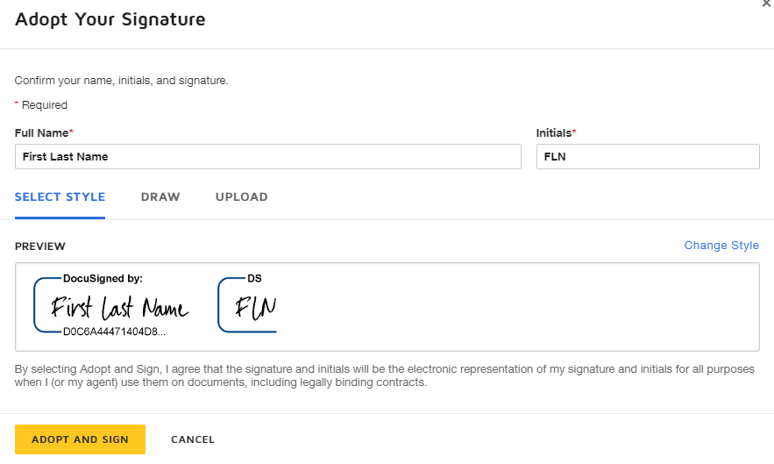

**Figure 4: Adopt Your Signature**

* A message with the following information displays:
  + Confirmation the contract was submitted for approval;
  + The status of the contract approval process is delivered to the email associated with the request;
  + The organization account will not be valid until the contract approval process completes; and
  + Click the “Back to Login” to close the dialog box and be routed to the HIE Login page (Reference Figure 1).
* An email from the RHA HIE Help Desk is delivered to the email associated with the account informing, “The information you provided has been sent to RHA for final approval. The results will be sent to this e-mail address as soon as the review is completed.”

### One Contract Per Organization

If a different user attempts to contract for the same organization, the system will issue a message stating, “The given Organization Name has already been registered.” The user will not be able to move forward with the contracting process.

## Contract Approval

The RHA team will review and validate the submitted contracting information. If valid and approved, an approval email will be sent to the organization contact with a copy of the electronically executed RHA HIE contract documents - RHA HIE Terms and Conditions and RHA HIE Participation Agreement. The email will also include a link to the HIE Login page (Reference Figure 1) to access the contract for review and approval.

The RHA team will send a denial email to the organization contact if the contracting information is not valid. Or if the RHA team cannot accommodate requests for special contracting considerations, terms or conditions. This activity will not be managed using the RHA HIE website.

# Completion

Having a fully executed contract between the organization and RHA completes the RHA HIE contracting process.

## Support

If help is needed throughout the contracting process, follow the instructions to submit a request form on the [Support](https://softdevinc.sharepoint.com/sites/SoftDev--Program-RSE-HIE/Shared%20Documents/General/Project%20Management/Deliverables/Requirements/User%20Guides/Renal%20Healthcare%20HIE%20Contracting%20User%20Guide/Support) page (https://rhahie.org/Support). Detailed instructions on using the Support Request Form is also available by clicking on the **Renal Healthcare HIE Support Request User Guide** link available on the website .

# Next Steps

## Facility Registration Overview

Each organization with an approved contract from the RHA for EQRS quality data reporting using the HIE may begin registering their individual facilities to report data for the patients at those facilities. Online registration is also where organizations can manage and update information for their registered facilities, such as contact information or facility identifiers.

The facility registration process creates identifiers for your facilities that you must give to your EHR vendor for set up of the electronic EQRS data submission process.

### Pre-Facility Registration

Before beginning the facility registration process,

* The organization must:
  + Have a valid CMS Certification Number (CCN)
  + Be registered with EQRS, and
  + Have an assigned EQRS Facility Identifier (ID)
* On Facility Registration page after login, click on the **Renal Healthcare HIE Facility Registration User Guide** link to view or download detailed instructions for the facility registration process.

### Facility Registration Process

* On the [Home](https://rhahie.org/) page (https://rhahie.org/), click “Login” located in the upper right side of the screen.
* On the HIE Login page (Reference Figure 1), enter your User Name and Password. Click “Login”.
* The Facility Registration page is displayed. Follow the detailed instructions in the **Renal Healthcare HIE Facility Registration User Guide** to complete the facility registration process.

## EHR Vendors Overview

The RHA HIE facilitates a process for EHR vendors to become certified to electronically submit data to the EQRS repository through the RHA HIE. This certification demonstrates the vendor has the technical capability to support this process. Once certification is obtained, the vendor may promote this capability as a feature of their software.

The certification process consists of several preparation and testing steps to submit production data to EQRS through the RHA HIE. This process includes:

* Preparing data files to meet the EQRS format and business rules requirements
* Testing for conformance
* Testing for data content and business rule compliance
* Connectivity and end-to-end testing

A complete overview and listing of steps in the certification process are outlined in the **Renal Healthcare HIE EQRS Certification Guide** available for viewing or downloading on the [For Vendors](https://rhahie.org/Vendor) page (https://rhahie.org/Vendor).

# Appendix A – Acronyms

This section provides definitions of acronyms referenced in this document.

**Table 1: Acronyms**

|  |  |
| --- | --- |
| **Acronym** | **Definition** |
| CCN | CMS Certification Number |
| CMS | Centers for Medicare and Medicaid Services |
| DBA | Doing Business As |
| EHR | Electronic Healthcare Record |
| EQRS | ESRD Quality Reporting System |
| ESRD | End Stage Renal Disease |
| HIE | Healthcare Information Exchange |
| ID | Identifier |
| RHA | Renal Healthcare Association |